Aymeric Lollichon de Baulny
Have big tech companies become a threat to democracies?
Index

Introduction: 1
In many ways, big tech companies threaten democracy. 1
They represent a threat to the electoral process. 1
They can be used by authoritarian governments to control the population. 2
They have a dangerous power of lobbying. 3
But in the past, they contributed to the rise of democracy and can still continue do to so 3
They contributed to the rise of a democratic spirit throughout the world 3
They allow some populations to access information. 4
They give a platform for expression to everyone 5
Conclusion 5
References 6

Introduction:
In July 2020, the CEOs of Apple, Google, Facebook, and Amazon were called to testify in Congress on their anti-competitive practices. House Judiciary Antitrust Chair David Cicilline during the hearing warned against the influence wielded by those giant firms: “Because these companies are so central to our modern life, their business practices and decisions have an outsized effect on our economy and our democracy. Any single action by any one of these companies can affect hundreds of millions of us in profound and lasting ways.”
Thus, we can wonder whether or not big tech companies have become a threat to democracies.

In many ways, big tech companies threaten democracy.

They represent a threat to the electoral process.
Shoshana Zuboff (2019) explained how these companies can manipulate people and influence their behaviour and thoughts including in the political field. She explains that these companies now use personal data as the main product of what she named “Surveillance Capitalism”. These companies exploit constant surveillance for their own financial gain, creating business models based on the collection, analysis, and sale of data. Indeed, Big-tech companies are blamed for manipulating internet users, mining their private data through cookies and then either selling the data collected without consent (as was seen in the Cambridge-Analytica scandal) or failing to protect privacy. The Cambridge Analytica consulting firm was accused of using the personal data of 50 million Facebook users in order to send targeted messages to people in favour of Trump’s election in 2016. By doing so they can influence political, economic and cultural decisions.
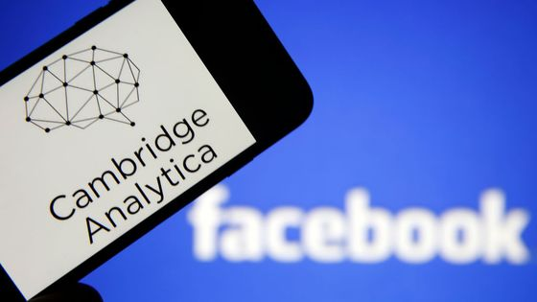
Logo of Facebook and Cambridge Analytica by Chesnot (CC0 1.0 Universal), via Getty
What's more, the phenomenon of fake news is also damaging the electoral process. With social media, this phenomenon has worsened due to the viral and wide distribution that they offer.
A new phenomenon has emerged on social media: the race to create buzz and the race to share new information. This technique allows unverified, erroneous or manipulative information to be relayed. Twitter, thanks to retweeting, can disseminate information seen by thousands of people in a matter of seconds without any verification.
For example, after the presidential election of 2020, Mr Trump did not hesitate to post false messages on his Twitter account indicating that the presidential election had been rigged and that he had won. Some of his messages even enticed his supporters to attack the institution that represents democracy: the Capitol.
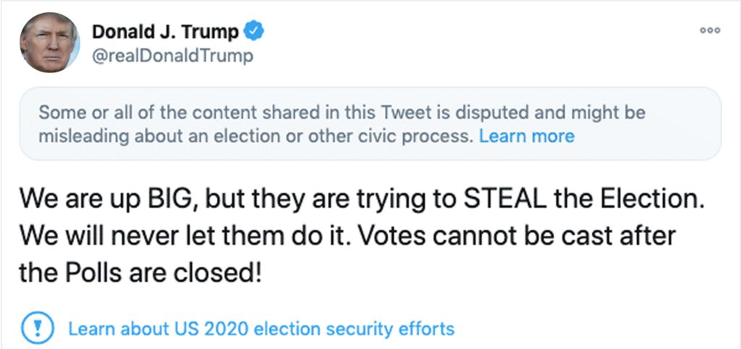
Tweet of Donald Trump the 4th of November 2020 explaining that he won the presidential election

They can be used by authoritarian governments to control the population.
The Internet also favours dictatorships and authoritarian regimes by enabling them to exercise effective control over their populations. According to Mark Lemley (2021), the Internet is a state tool for internal control and cohesion and Russia and China state controlled the Internet for political gains. It allows them to control the population.

They have a dangerous power of lobbying.
The money invested by those companies in lobbying is worrying. Their action can be to sway legislation likely to curb their power (such as antitrust laws in the US), or to make the institutions create new laws more favourable to their interest. These companies practice lobbying throughout the world and thus have a huge influence on the political decisions taken.
For instance, according to the research(Lobbying Power of Amazon, Google and Co. Continues to Grow | Corporate Europe Observatory, 2023) we can estimate that big tech companies spend 113 million euros every year on lobbying the European commission.
Big Tech’s huge lobbying budgets have a significant impact on EU policy-makers, who find digital lobbyists knocking on their door on a regular basis. The EU’s attempt at reining in Big Tech, provides the perfect example of how the firms’ immense budget provides them with privileged access: Commission high-level officials held 271 meetings, 75% of them with industry lobbyists. Google and Facebook led the pack.
Thus, according to T. Valletti (former Chief Economist of the Competition Directorate of the EU Commission), “The economic and political power of the digital giants is hefty, and they are not going to remain passive in the face of possible new rules that effect the way they conduct their business. That is why the EU Institutions urgently need to change the way they handle this lobbying and limit the power of big tech.“.
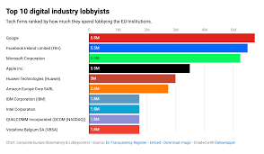
Chart: Corporate Europe Observatory & Lobbycontrol Source: EU Transparency Register Embed Download image Created with Datawrapper.

But in the past, they contributed to the rise of democracy and can still continue do to so

They contributed to the rise of a democratic spirit throughout the world
The increasingly widespread use of social media and their global reach are helping to raise democratic awareness.
Through this channel, marginalised or oppressed groups can compare their socio-political situation with that of other people and react accordingly.
Furthermore, Tufekci (2017) explains that social media has facilitated the rapid mobilisation of individuals and groups during social movements and protests, enabling the rapid dissemination of information and creating spaces for online coordination.
The Arab Spring is a timely example. During the Arab Spring, social networks were used to organise demonstrations and bypass the traditional media to disseminate images, testimonies and evidence of anti-democratic behaviour (police abuse, brutality...) Social networks helped to maintain the momentum of the demonstrations and thus contributed to the overthrow of the three dictators in Tunisia, Egypt and Libya in 2011. After the fall of President Ben Ali in January 2011, a graffiti saying "Thank you Facebook! “appeared on the emblematic Avenue Bourguiba in central Tunis. Many consider Ben Ali to be a dictator.
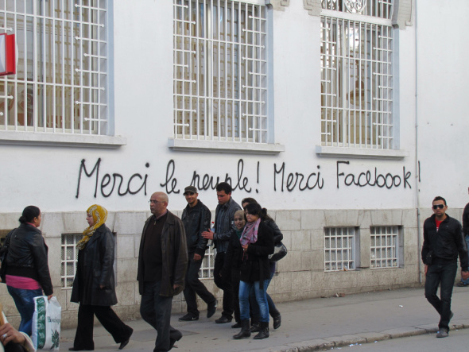
Picture of a street in Tunisia in 2011

They allow some populations to access information.
Social media has become the preferred source of information for Internet users. Facebook, Twitter and YouTube are the top three sources of new news, to the detriment of the traditional media.
Thanks to the smartphone, social media is proving to be more effective than traditional media in attracting users to news content. Access to information is simple, free and available at any time of day. And even if the phenomenon of fake news mentioned above is real and significant, overall, social networks still provide access to quality information in many cases. Furthermore, many people created accounts on social media on which they provide a certified information.
The access to information is essential for a democracy so that everyone can make the most judicious choices.
Picture of Hugo Décrypte (a French youtuber who relays the most important news of the day every day to his followers) interviewing Emmanuel Macron,

They give a platform for expression to everyone
Social media (Facebook, Twitter…) are counterpowers to governments and convey the contrasted views of every political party, every group (from liberal CNN to conservative Fox News) and activists. By doing that, they secure the diversity of opinions and free speech, inherent in any democracy and enshrined in the US Constitution.

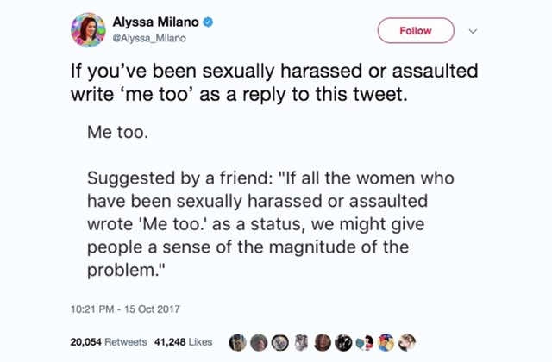
Tweet of Alyssa Milano, one of the women at the origin of "me too" movement
Social media has liberated speech. It has enabled citizens, regardless of their geographical location or social status, to take part in public debate, share their opinions and express their ideas across party lines, thereby contributing to the democratic process in their country. In all areas of national life, citizens can make their voices heard and to have them taken into account.

Conclusion
Democracies can still rely on powerful institutions and whistleblowers to withstand the power of big tech.
Furthermore, the dangers that big tech companies represent seem to be more related to excesses than to the very existence of these big tech companies themselves. We can thus imagine that a good legislation is possible to prevent these companies from using the personal data of the consumers in dangerous ways. Furthermore, we need to make more prevention on population to warn people to be careful when they see information on social media and to check the source of the information. The issue of lobbying too could be tackled by the national and supranational institutions.

References
Graham-Harrison, E., & Cadwalladr, C. (2018, March 17). Revealed: 50 million Facebook profiles harvested for Cambridge Analytica in major data breach. The Guardian. https://www.theguardian.com/news/2018/mar/17/cambridge-analytica-facebook-influence-us-election
Lemley, M. A. (2021). The splinternet (Vol. 70, pp. 1397–1427). Duke Law Journal.
Lobbying power of Amazon, Google and Co. continues to grow | Corporate Europe Observatory. (2023, September 8). Corporateeurope.org. https://corporateeurope.org/en/2023/09/lobbying-power-amazon-google-and-co-continues-grow
Robertson, A. (2020, July 29). Everything you need to know from the tech antitrust hearing. The Verge. https://www.theverge.com/2020/7/29/21335706/antitrust-hearing-highlights-facebook-google-amazon-apple-congress-testimony
Rosen, R. J. (2011, September 3). So, Was Facebook Responsible for the Arab Spring After All? The Atlantic; The Atlantic. https://www.theatlantic.com/technology/archive/2011/09/so-was-facebook-responsible-for-the-arab-spring-after-all/244314/
The lobby network: Big Tech’s web of influence in the EU | Corporate Europe Observatory. (2021, August 31). Corporateeurope.org. https://corporateeurope.org/en/2021/08/lobby-network-big-techs-web-influence-eu
Tufekci, Z. (2018). Twitter and tear gas: The power and fragility of networked protest. Yale University Press.
Zuboff, S. (2019). AGE OF SURVEILLANCE CAPITALISM : the fight for a human future at the new frontier of power. Public Affairs.

